Limestone
1. The periodic table on the Data Sheet might help you to answer this question.
Diagrams A – D show models of four different molecules.

Complete the table to give the name and the formula of each of the molecules A – D.
The first one has been done for you.
Molecule | Name | Formula
A | Hydrogen | H2
B
C
D
(Total 6 marks)

2. There are millions of different substances that make up our world. All these substances are made from chemical elements.
(a) What is an element?
.....................................................................................................................................
.....................................................................................................................................
(1)

(b) Many substances are compounds. What is a compound?
.....................................................................................................................................
.....................................................................................................................................
.....................................................................................................................................
.....................................................................................................................................
(2)
(Total 3 marks)

3. The diagram represents an atom. Choose words from the list to label the diagram.
electron ion neutron nucleus
(Total 3 marks)

4. Calcium oxide (quicklime) is made by heating calcium carbonate (limestone).
calcium carbonate → calcium oxide + carbon dioxide
100g ? 44g
(a) 44 grams of carbon dioxide is produced when 100 grams of calcium carbonate is heated.
Calculate the mass of calcium oxide produced when 100 grams of calcium carbonate is heated.
....................................................................................................................................
mass ......................... g
(1)

(b) What mass of carbon dioxide could be made from 100 tonnes of calcium carbonate?
mass ....................... tonnes
(1)
(Total 2 marks)

5. An old lime kiln made in the ground is shown.

(a) The thermal decomposition of calcium carbonate makes a white solid and carbon dioxide.
(i) Name a naturally occurring form of calcium carbonate.
...........................................................................................................................
...........................................................................................................................
(1)

(ii) What does thermal decomposition mean?
...........................................................................................................................
...........................................................................................................................
(2)

(iii) Suggest and explain the purpose of the coal.
...........................................................................................................................
...........................................................................................................................
...........................................................................................................................
(2)

(iv) Write a word equation for the thermal decomposition of calcium carbonate.
................................... → ................................... + ....................................
(2)

(b) The diagrams show what happens when drops of cold water are added to the white solid formed by heating calcium carbonate.
(ii) What type of chemical reaction takes place?
...........................................................................................................................
(1)

(ii) Give the chemical name of the solid formed. Give a use of this solid.
Name ................................................................................................................
Use ...................................................................................................................
(2)
(Total 10 marks)
6. Limestone is a useful rock.
(a) Limestone can be used to make several useful products.
Draw rings around two useful products made from limestone.
cement diesel glass petrol plastic
(2)

(b) A student did some experiments to study limestone.
In one experiment, a piece of limestone was heated very strongly as shown in the diagram.

(i) Suggest one safety precaution that the student should take when doing this experiment.
...........................................................................................................................
...........................................................................................................................
(1)
(ii) When limestone is heated it forms two products; a white powder and a gas.
Complete the word equation by choosing the correct product from the list.
calcium carbide calcium hydroxide calcium nitride calcium oxide
calcium carbonate …………………………………..…… + carbon dioxide
(limestone)
(1)
(c) The student did another experiment using 2.00 grams of limestone.
The limestone was weighed before and after being heated.
The student then repeated this experiment.
A new sample of 2.00 grams of limestone was used.
The results are shown in the table.
 | Experiment 1 | Experiment 2
Mass of limestone before heating  in grams (g) | 2.00 | 2.00
Mass of limestone after heating  in grams (g) | 1.12 | 1.10
Mass lost in grams (g) | 0.88 | 0.90

(i) Calculate the average mass lost for the two experiments.
...........................................................................................................................
Average mass lost = .............................................. g
(1)
(ii) Explain why it was important for the student to repeat this experiment.
...........................................................................................................................
...........................................................................................................................
(1)
(iii) Suggest why the mass lost was not the same for the two experiments.
...........................................................................................................................
...........................................................................................................................
(1)

(iv) Explain why a balance which measures to the nearest 0.1 g would not be suitable for this experiment.
...........................................................................................................................
...........................................................................................................................
(1)
(v) Suggest what mass of carbon dioxide would be produced when 2.00 g of limestone is heated.
Mass of carbon dioxide produced = ........................g
(1)
(d) The drawing shows a limestone quarry.
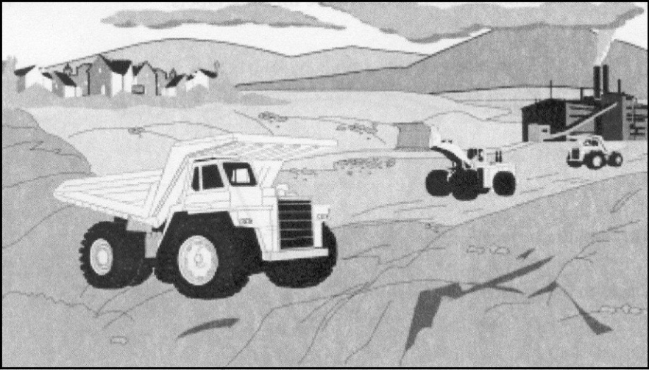

(i) Suggest two ways in which the limestone quarry may harm the environment.
1 ........................................................................................................................
...........................................................................................................................
...........................................................................................................................
2 ........................................................................................................................
...........................................................................................................................
(2)
(ii) Suggest two ways in which the limestone quarry is of benefit to people.
1 ........................................................................................................................
...........................................................................................................................
2 ........................................................................................................................
...........................................................................................................................
(2)
(Total 13 marks)

7. Limestone is an important raw material.
(a) The main compound in limestone has the formula CaCO3 .
Name the elements in this compound.
1 .................................................................................................................................
2 .................................................................................................................................
3 .................................................................................................................................
(2)
(b) Limestone has many uses. Select from the list below two important materials made from limestone.
cement diesel oil glass
poly(ethene) sodium hydroxide sulphuric acid
.............................................................. and ..............................................................
(2)
(c) The diagram shows a lime kiln. The limestone is heated by the burning coal.
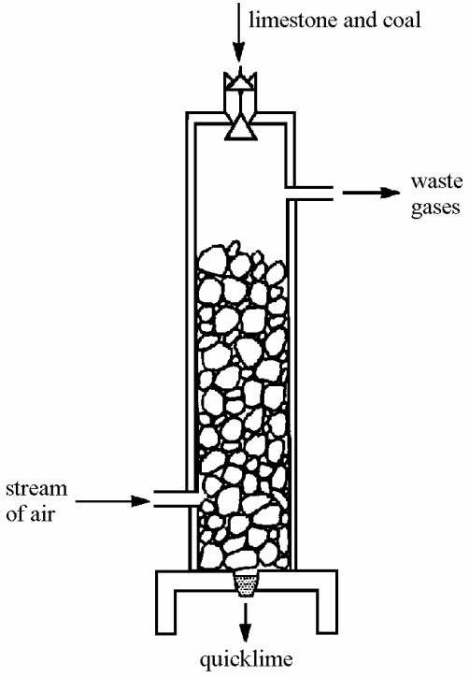

(i) Suggest why hot air is blown into the lime kiln.
............................................................................................................................
............................................................................................................................
(1)
(ii) Give two reasons why carbon dioxide is produced in the lime kiln.
Reason 1 ............................................................................................................
............................................................................................................................
Reason 2 ............................................................................................................
............................................................................................................................
(2)

(d) (i) Quicklime (calcium oxide) can be converted to slaked lime (calcium hydroxide) by adding water.
Write a word equation to represent this reaction.
...................................... + ...................................... → ....................................
(1)

(ii) Why do farmers sometimes add slaked lime to acidic soil?
...........................................................................................................................
...........................................................................................................................
(1)
(Total 9 marks)

