Polymers

Draw a section of the polymer that contains 3 monomers based on these starting monomers:

Monomer | Polymer section (3 monomers)
Ethene
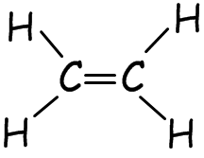
Chloroethene
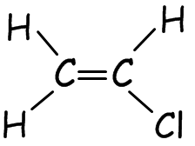
Propene
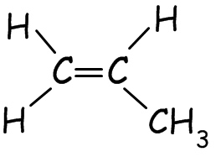

Now reverse the process: draw the monomer(s) based on the polymer:

Monomer(s) | Polymer section
Polystyrene
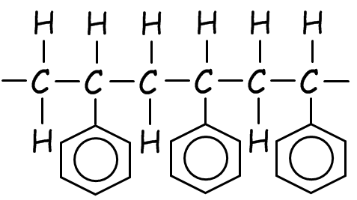
 | 