All objects emit and absorb what?

The 3 types of energy transfer are...

How do particles transfer heat energy by conduction?

Does this happen in solids, liquids or gasses?

What are the 3 states of matter?

Draw a diagram of each state.

In which of these states do particles have more energy?

Which objects will **reflect** more infrared radiation?

* Light and shiny
* Dark and matt

Which objects will **absorb** and **emit** more infrared radiation?

* Light and shiny
* Dark and matt
* Dark and matt
* Light and shiny
* Conduction
* Convection
* Radiation
* Infrared radiation

[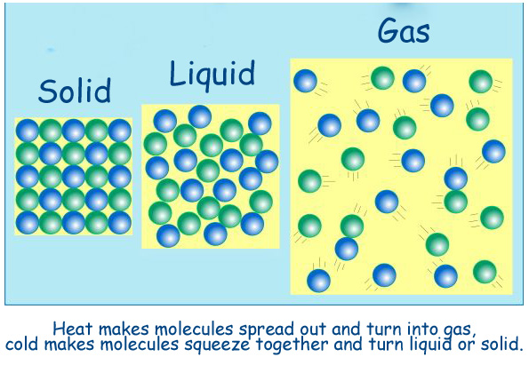](http://www.google.co.uk/url?sa=i&rct=j&q=&esrc=s&frm=1&source=images&cd=&cad=rja&uact=8&docid=cAs2_3W8XNZunM&tbnid=AKY7HlGHdHcfSM:&ved=0CAUQjRw&url=http://jmsalsich.edublogs.org/2010/05/31/liquid-nitrogen/&ei=Z4tmU5uHCIHBOL7CgJAO&bvm=bv.65788261,d.ZGU&psig=AFQjCNFN9RvlClfeXn4PI4Pvdnu_pNLZxw&ust=1399315668544169)

* Particles have the most energy in gasses and the least energy in solids.
* Particles nearest the heat source gain energy and vibrate more. They collide into neighbouring particles and pass on some of their energy.
* Conduction happens mostly in solids. In liquids it happens slower and in gasses it happens very slowly.

Heat energy is transferred quickest from a…

* hot object to cold object
* warm object to cold object

The rate at which an object transfers energy by heating depends on...

How do particles transfer heat energy by convection?

How do free electrons make metals good conductors?

What is CMBR?

Where did it come from?

What theory explains its existence?

What do U-values measure?

What does a low U-value tell you?

* hot object to cold object

[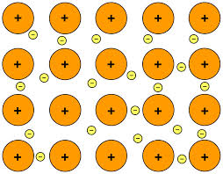](http://www.google.co.uk/imgres?imgurl=http://upload.wikimedia.org/wikipedia/commons/8/85/Metallic_bonding.svg&imgrefurl=http://answerparty.com/question/answer/what-are-two-important-properties-of-metals-that-can-be-explained-by-metallic-bonding&h=600&w=770&tbnid=My6GrApW-NZGAM:&zoom=1&docid=ccbpfb9cV8NxJM&hl=en&ei=ko5mU5TTG5CA7Qa9-YCQBw&tbm=isch&ved=0CHUQMygVMBU&iact=rc&uact=3&dur=608&page=2&start=18&ndsp=21)

* The free electrons can move through the metal. They move faster at the hot end and collide with other free electrons, transferring some of their energy.

[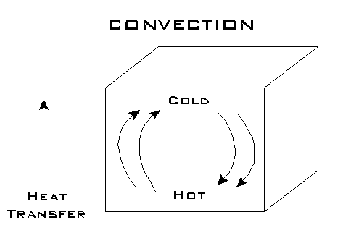](http://www.google.co.uk/url?sa=i&rct=j&q=&esrc=s&frm=1&source=images&cd=&cad=rja&uact=8&docid=s2c2WwdbXfrenM&tbnid=EnLmODt6m8pV-M:&ved=0CAUQjRw&url=http://www.fi.edu/guide/hughes/heattransfer.html&ei=hpJmU-reCI7jO9mbgfgJ&bvm=bv.65788261,d.ZGU&psig=AFQjCNHwcpO4uwzEiiv7b07LlGXjcixeew&ust=1399317493433326)

* Particles in liquids or gasses near the heat source gain energy and move faster. The water/air becomes less dense and rises to a cooler area. Then they transfer energy to nearby particles.
* U-values measure how effective a material is as an insulator.
* The lower the U-value, the better the material is as an insulator.
* Cosmic microwave background radiation.
* It comes from radiation that was present shortly after the beginning of the universe.
* The Big Bang is the only theory to currently explain its existence.
* Surface area and volume
* The material the object is made from
* The type of surface of the object e.g. dark, light, shiny, matt

What does energy efficiency mean?

Why are no electrical appliances 100% efficient?

What does 'pay-back time' mean?

How can houses be insulated?

What is specific heat capacity a measure of?

What do these symbols stand for in the equation?

E = m x c x θ

What are the 9 types of energy?

Energy can be...

but it can't be ...

Where does wasted energy go?

[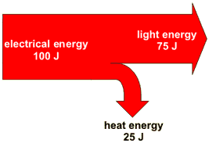](http://www.google.com/url?sa=i&rct=j&q=&esrc=s&frm=1&source=images&cd=&cad=rja&uact=8&docid=uSJMdkwESQTxVM&tbnid=3FddZpW6pSOwqM:&ved=0CAUQjRw&url=http://www.bbc.co.uk/schools/gcsebitesize/science/add_ocr_pre_2011/electric_circuits/mainselectricityrev3.shtml&ei=jZlmU6foE4r-PKqDgagP&bvm=bv.65788261,d.ZGU&psig=AFQjCNEOaanGG-5C3-7O_ZOsfE3hc2C7Gw&ust=1399319274599215)

How efficient is this light bulb?

* Energy efficiency is how much of the input energy is transformed into useful energy
* No appliance is 100% efficient because some wasted energy is usually spread out to nearby particles as heat energy.

75 x 100 = 75%

100

or

75 = 0.75

100

* The amount of energy required to change the temperature of one kg of the substance by 1°C
* E = energy transferred in joules (J)
* m = mass (kg)
* c = specific heat capacity (J/kg °C)
* θ = temperature change (°C)
* Pay-back time = how long it takes for the money you've saved on heating bills to equal the cost of the insulation.
* Loft insulation
* Cavity wall insulation
* Hot water tank jacket
* Carpets rather than wooden floor
* Curtains rather than blinds
* Energy can be transferred, stored or spread out but it can't be created or destroyed.
* Wasted energy is transferred to the surrounding air, which then becomes warmer.
* Electrical
* Light
* Sound
* Kinetic (aka movement)
* Nuclear
* Thermal (aka heat)
* Gravitational potential
* Elastic potential
* Chemical (in food, fuels & batteries)

All waves transfer what?

Draw a longitudinal wave.

Draw a transverse wave.

All waves can be r_____, r_____ and d_____

How does electricity get from power stations to homes?

What are the different parts of this system?

How does current and voltage play a role in this system?

How does a fossil fuel power station generate electricity?

What are the energy transfers that happen in this process?

Name 4 non-renewable energy sources.

Name 7 renewable energy sources

(By the way - you need to know pros and cons of each of these.)

The cost of electricity is measured in...

The amount of energy an appliance transfers depends on...

* Waves transfer energy.

Longitudinal wave

[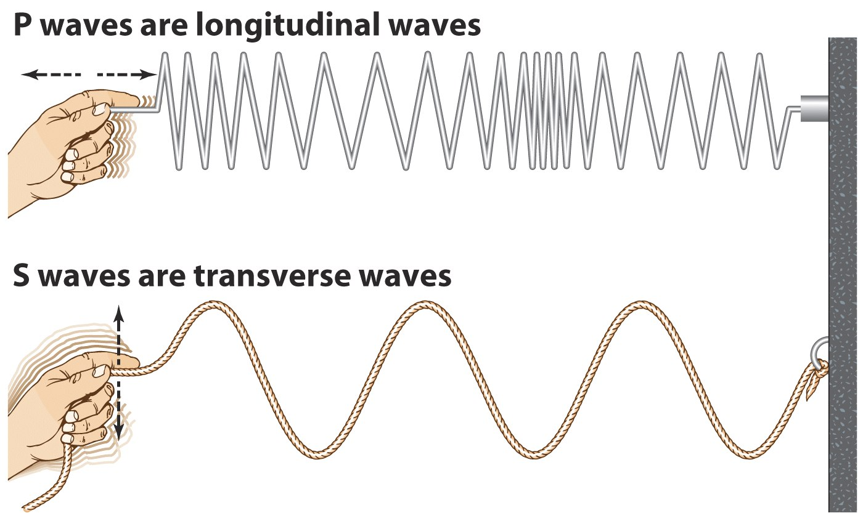](https://www.google.com/url?sa=i&rct=j&q=&esrc=s&frm=1&source=images&cd=&cad=rja&uact=8&docid=3DGqN-1fYJP6yM&tbnid=Vd1-o3YDwJCc7M:&ved=0CAUQjRw&url=https://gcps.desire2learn.com/d2l/lor/viewer/viewFile.d2lfile/6605/8091/index.html&ei=LKVmU6b3AeSa0QWRsIGQBQ&bvm=bv.65788261,d.ZGU&psig=AFQjCNFIxdjChLTuRZWahV0V1m62XonKkQ&ust=1399322218499686)

Transverse wave

[](https://www.google.com/url?sa=i&rct=j&q=&esrc=s&frm=1&source=images&cd=&cad=rja&uact=8&docid=3DGqN-1fYJP6yM&tbnid=Vd1-o3YDwJCc7M:&ved=0CAUQjRw&url=https://gcps.desire2learn.com/d2l/lor/viewer/viewFile.d2lfile/6605/8091/index.html&ei=LKVmU6b3AeSa0QWRsIGQBQ&bvm=bv.65788261,d.ZGU&psig=AFQjCNFIxdjChLTuRZWahV0V1m62XonKkQ&ust=1399322218499686)

* All waves can be reflected, refracted and diffracted.
* Non-renewable:

Coal, oil, gas, nuclear

* Renewable:

Wind, waves, tides, hydroelectric, solar, geothermal, bio fuels

* Coal/oil/gas in burnt to heat up water into steam.
* The steam turns a turbine.
* The spinning turbine turns a generator.
* The spinning generator generates electricity.

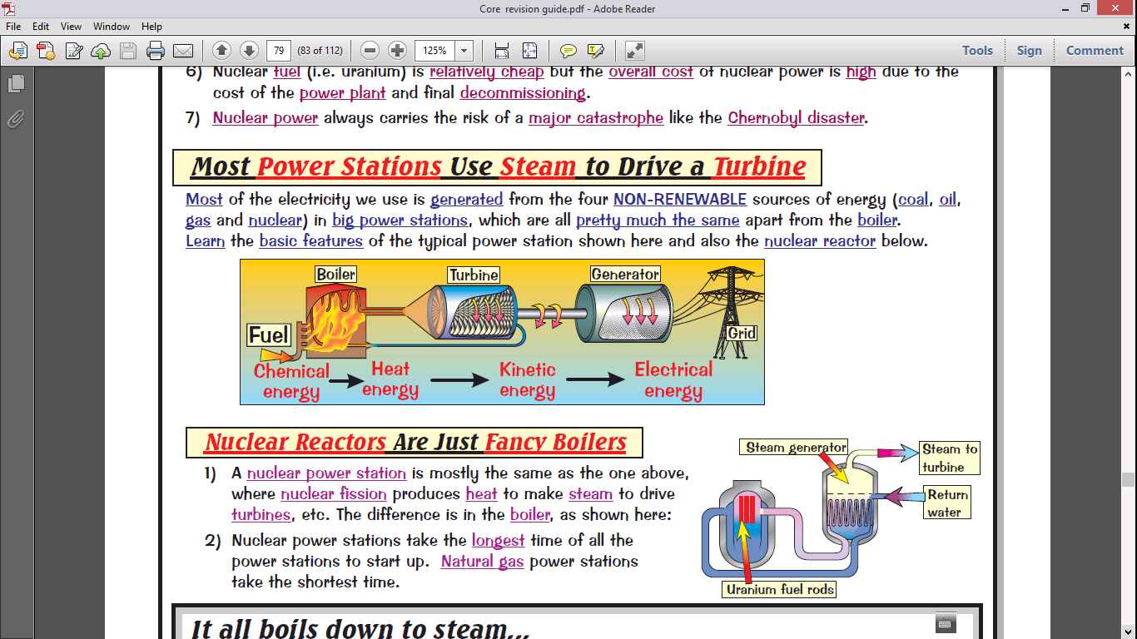

* How long the appliance is switched on for and its power.

E = p *x* t

(Energy = power x time)

* Kilowatt-hours
* The national grid.
* Step up transformer, Transmission cables, Step down transformer
* Step up transformer = voltage increases & current decreases to reduce heat energy loss along the cables.

Step down = voltage decreases & current increases.

Describe the Doppler effect.

1. Are sound waves longitudinal or transverse waves?
2. The pitch of a sound is determined by what?
3. The loudness of a sound is determined by what?
4. What are echoes?

How are Radio waves, microwaves, infrared and visible light used for communication?

Red-shift gives us evidence for what?

Describe the theory it gives us evidence for.

Describe red-shift.

In the Doppler effect, how does the wavelength and frequency change when the object moves:

* Towards you?
* Away from you?
* If a light/sound source is moving away from or towards you there will be a change in the wavelength and frequency that you detect.

This is known as the Doppler effect.

* When the source moves towards you, the observed wavelength decreases and the frequency increases.
* When the source moves away from you, the observed wavelength increases and the frequency decreases.
* radio waves – television and radio
  + microwaves – mobile phones and satellite television
  + infrared – remote controls
  + visible light - photography

1. Longitudinal waves
2. Frequency
3. Amplitude (height of the wave)
4. Reflection of sounds

* When we look at distant galaxies, the light coming from them looks red.
* It seems that the wavelength of light has increased.
* The further away the galaxies are, the faster they are moving, and the bigger the increase in wavelength (they look redder).
* This effect is called red-shift.
* The Big Bang.
* The universe is expanding and started from a very small initial point.

All electromagnetic waves:

* Travel at this speed...
* Can travel through a ...

Name the 7 electromagnetic waves starting with the wave that has the least energy, lowest frequency and longest wavelength.

Draw a transverse wave and label the:

* wavelength
* peak
* trough
* amplitude

Draw a diagram to show refraction through a glass block.

Draw a diagram to show the reflection of a beam of light off a plane mirror. Label the angle of incidence and angle of reflection.

Draw a diagram to show diffraction of a wave when…

* The wavelength is much smaller than the gap
* The wavelength is the same size as the gap
* Radio waves
* Microwaves
* Infrared waves
* Visible light
* Ultraviolet
* X-rays
* Gamma rays
* Travel at the speed of light, 300,000,000 m/s.
* Can travel through a vacuum.

[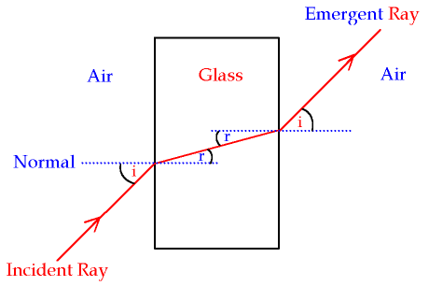](http://www.google.co.uk/url?sa=i&rct=j&q=&esrc=s&frm=1&source=images&cd=&cad=rja&uact=8&docid=SkKTc3r0hbIndM&tbnid=1vfBqDiZRRhr3M:&ved=0CAUQjRw&url=http://www.gcsescience.com/pwav23.htm&ei=cq1mU7nnF-er0QXq3oCQDg&bvm=bv.65788261,d.d2k&psig=AFQjCNHfRX_axz7u_OxCwp-mXuU1PSKDwA&ust=1399324397700827)

[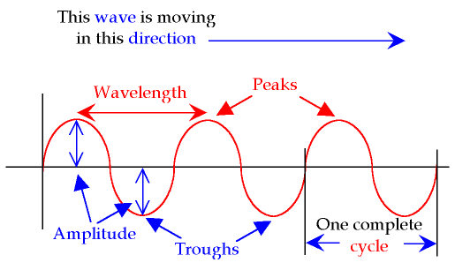](http://www.google.com/url?sa=i&rct=j&q=&esrc=s&frm=1&source=images&cd=&cad=rja&uact=8&docid=06MWK53vd2EuBM&tbnid=rkvCBezHxHZF_M:&ved=0CAUQjRw&url=http://www.gcsescience.com/pwav4.htm&ei=NaZmU83lGoX00gXt4YDwDw&bvm=bv.65788261,d.ZGU&psig=AFQjCNHCqBUo9dOZK4nN2oAClpFUzRp8Ng&ust=1399322428031426)

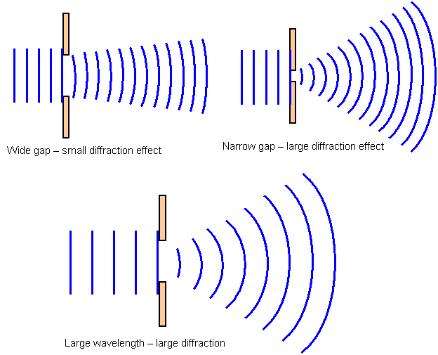



[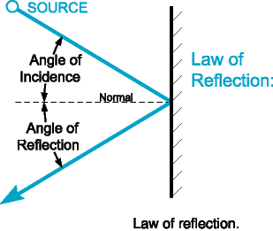](https://www.google.com/url?sa=i&rct=j&q=&esrc=s&frm=1&source=images&cd=&cad=rja&uact=8&docid=dl2vPRM_XR2WQM&tbnid=yVhJW9-pLXxz1M:&ved=0CAUQjRw&url=https://isb-ibphysics-dawghouse.wikispaces.com/Topic+04.5&ei=GKhmU_2NF6jX0QWFzYCYCw&bvm=bv.65788261,d.ZGU&psig=AFQjCNFYHdN1krFhvxhpWxkxp6Gd3NXmEg&ust=1399322930673618)